THEORY QUESTIONS
1.
Study the text below carefully and use it to answer questions (a) to (g)
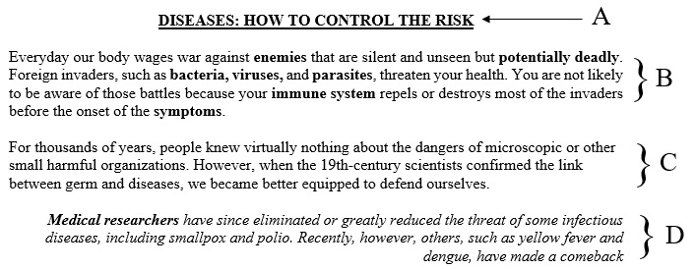
a)

Write down the application software that was used to create the above text.
b)

List two examples of the application software mentioned in (a) above.
c)

Give the name of the text area labelled A.
d)

Write down the name of the font styles applied to the following words in the text:
i)

potentially deadly
ii)

harmful organisms
iii)

Medical researchers
e)

Write down the type of alignment applied to the paragraphs labelled B, C and D in the text
f)

List the steps used in underlining the words in the text area labelled A which was typed with the caps lock key on.
g)

Write down the name given to the process of applying the various styles and paragraphs to the text.

2.
a)

Using the table below, indicate where the following components can be seen on the computer system unit.
CD/DVD slot, CPU, Flopy disk slot, Memory, Motherboard, Power button, Power supply port, PS/2 port, VGA port.
BACK VIEW | FRONT VIEW | INSIDE VIEW
b)

What is copyright?

3.
Explain the following computer terms:
a)

Hardware
b)

Network
c)

Software
d)

Virus

4.
a)

State the function of each of the following devices:
i)

floppy disk
ii)

keyboard
iii)

uninterruptible power supply
b)

Explain each of the following terms:
i)

Clicking
ii)

Dragging

5.
State three uses of computers in each of the following areas:
a)

Education
b)

Everyday life

